

**Submitted by:**

**Kapil Upadhyay (12416120)**

**Section - D2442**

**Group - G1**

**Roll no. - 01**

**Lovely faculty of Technology & Sciences**

**School of Computer Applications**

**Lovely Professional University**

**Punjab**

**Submitted To:**

**Dr.Mirza Shuja**

**Software Engineering Practices**

**Automation Testing using Selenium IDE**

**On theathletic.com**

| Sr. No. | Content |
| --- | --- |
| 1 | Test Plan Identifier |
| 2 | References |
| 3 | Introduction |
| 4 | Test Items |
| 5 | Software Risk Issue |
| 6 | Features to be Tested |
| 7 | Features not to be Tested |
| 8 | Approach |
| 9 | Item Pass/ Fail Criteria |
| 10 | Suspension Criteria & Resumption Requirements |
| 11 | Test Deliverables |
| 12 | Remaining Test Task |
| 13 | Environmental Needs |
| 14 | Staffing & Training needs |
| 15 | Responsibility |
| 16 | Schedule |
| 17 | Planning Risks and Contingencies |
| 18 | Approval |

|  |  |  |
| --- | --- | --- |
| 19 | Glossary | 9 - 11 |

**Test Plan for Indeed.com**

**1. Test Plan Identifier**

This test plan is focused on Testing the "www.theathletic.com" website using Selenium IDE. The test plan will consist of several test cases, each designed to verify specific functionalities of the “Indeed” website. To ensure a comprehensive evaluation, tests will be conducted across various browser types and operating systems.

**2. References**

* Official www.theathletic.com website - www.theathletic.com
* Selenium IDE Documentation.

**3. Introduction**

**Purpose**  
To validate the functionality, usability, and performance of **TheAthletic.com** website. The primary goal is to ensure the website’s features function reliably, providing a seamless user experience through automated testing using Selenium IDE.

**Scope**  
Testing will cover the following core functionalities:

1. Searching Functionality
2. Tickets Booking
3. Restrictions of Payment When Opening Certain Articles
4. Sharing or Inviting Friends
5. Subscription Management

**Objectives**

* Verify whether the **Search Functionality** retrieves accurate results.
* Ensure **Tickets Booking** is working seamlessly from selection to confirmation.
* Validate the **Payment Restrictions** feature when accessing restricted content.
* Test the **Sharing or Inviting Friends** option for smooth integration and functionality.
* Confirm proper functioning of the **Subscription Management** module, including sign-ups and renewals.

**4. Test Items**

* **Search Functionality**:  
  A tool enabling users to find articles, news, or sports information quickly. The function refines results based on user-provided keywords.
* **Tickets Booking**:  
  A system allowing users to book tickets for sports events or other related activities. This module covers seat selection, payment, and confirmation.
* **Payment Restrictions for Articles**:  
  Mechanism to restrict access to premium articles unless the user subscribes or pays a fee.
* **Sharing or Inviting Friends**:  
  Enables users to share articles or invite friends to join The Athletic platform, often using email or social media integration.
* **Subscription Management**:  
  A feature that allows users to sign up for a subscription, manage existing plans, and renew or cancel them.

**5. Software Risk Issues**

* **Dynamic Content**:  
  The Athletic may utilize dynamically generated elements that could lead to failed test cases if elements cannot be located during testing.
* **CAPTCHA/Bot Detection**:  
  Automated tests could be blocked by CAPTCHA or bot-detection mechanisms implemented to secure sensitive operations like subscriptions.
* **Cross-Browser Compatibility**:  
  Selenium IDE may not account for all platform-specific or browser-specific behaviors.
* **Payment Gateway Testing**:  
  Involves third-party gateways with sensitive data, which could limit testing scope.

**6. Features to be Tested**

* **Search Functionality**:  
  Testing by entering relevant keywords for sports events or articles and validating the returned results using Selenium IDE automation.
* **Tickets Booking**:  
  Testing the entire flow of ticket booking—from event selection, seat reservation, payment processing, to final confirmation.
* **Restrictions**:  
  Testing by accessing restricted articles and ensuring payment prompts appear correctly, blocking unauthorized access.
* **Sharing or Inviting Friends**:  
  Testing whether articles or invite links are shared successfully via email or social platforms.
* **Subscription Management**:  
  Testing subscription functionality by signing up, renewing, and canceling a subscription, ensuring all actions are reflected accurately.

**7.Features Not to be Tested**

* **CAPTCHA or Bot Detection**:  
  Tests will not cover CAPTCHA as it requires manual intervention.
* **Performance Metrics**:  
  The scope does not include performance or load time testing since Selenium IDE is not designed for such analyses.
* **Third-Party Payment Gateways**:  
  Transactions involving third-party gateways or sensitive user data will not be directly tested.

**8. Approach**

Automated testing will be conducted using **Selenium IDE** on Google Chrome. The testing process involves executing each test case and recording the results to ensure reliable functionality.

* **Test Cases**:  
  Five test cases have been identified and automated using Selenium IDE.
* **Execution**:  
  All test cases will be executed on the latest version of Google Chrome.

**9. Item Pass/Fail Criteria**

There are two criteria for evaluating the test outcomes:

* **Pass**:  
  The test is marked as "Pass" if the feature performs as expected without errors or unexpected outputs during execution.
* **Fail**:  
  The test is marked as "Fail" if an error or issue occurs during execution (e.g., incorrect response code, missing elements, or unhandled exceptions). Selenium IDE will log these issues.

**10. Suspension Criteria and Resumption Requirements**

Testing may be suspended under the following conditions:

* **Server Downtime or Maintenance**:  
  Testing will be halted if **TheAthletic.com** undergoes maintenance or the server becomes unavailable.
* **Third-Party Dependency Issues**:  
  Testing will pause if third-party APIs (e.g., payment gateways or social sharing services) fail or become unresponsive.
* **Test Environment Issues**:  
  Any errors or instability in the test environment will result in suspension. Testing will resume only after the issue is resolved.

**11. Test Deliverables**

The following deliverables will be provided upon completion of testing:

1. **Test Case Scripts**:  
   Selenium IDE test scripts used for automation.
2. **Test Execution Reports**:  
   A detailed summary of test results, including screenshots for failed test cases.
3. **Logs**:  
   Defect logs documenting any issues encountered during testing.

**Test Case Summary:**

| **Test Scenario** | **Execution Details** |
| --- | --- |
|  |  |
| **Website URL** | [TheAthletic.com](https://www.theathletic.com/) |
| **Tester** | Sheetal Sambyal |
| **Date** | 24-11-2024 |

**12.Remaining Test Tasks:**

1. Cross device tests – The tests must be executed in other devices like mobile phones as well.
2. Cross-Browser Testing--Validate functionality on various browsers like Chrome, Firefox, Safari, and Edge

**13.Environmental Needs:**

1. Web Browser latest .
2. Test environment: Arch Linux laptop with Brave and Firefox browsers.
3. Stable internet connection.
4. Selenium IDE

**14.Schedule:**

From [15/11/2024] to [16/11/2024]: Test Plan Creation.

From [17/11/2024] to [18/11/2024]: Test Execution.

From [19/11/2024] to [20/11/2024]: Finalizing & Reporting **.**

**15.Planning Risks and Contingencies:**

Risk 1: Delays due to website maintenance or updates.

During the process of maintaining and updating a website, several contingencies may arise. These unforeseen incidents could range from temporary service interruptions, data loss, or even compatibility issues with certain web browsers or devices.

Risk 2 :Selenium IDE compatibility issues with the website elements.

Compatibility issues between Selenium IDE and certain website elements can pose significant risks during automation testing. These challenges may arise from discrepancies in how different browsers interpret or render specific web components, leading to inconsistencies in different tests.

**16.Glossary**

**Test Case Scripts**:

|  |  |  |  |  |  |  |  |  |  |
| --- | --- | --- | --- | --- | --- | --- | --- | --- | --- |
| **ID** | **Test Case** | **Pre-condition** | **Test Steps** | **Test Data** | **Expected Output** | **Post-condition** | **Actual Output** | **Status** |  |
| Tickets_001 | Verification of Ticket Navigation | User must be on the Athletic UK homepage | 1. Open the Athletic UK homepage | Valid Athletic UK homepage URL | Successful navigation to the Tickets page | Tickets page is accessible | Tickets page loaded successfully | Pass |  |
| 2. Hover over the navigation menu | Valid navigation clicks |  |
| 3. Click on "Tickets by Viagogo" |  |  |
| 4. Scroll to the top of the page |  |  |
| 5. Scroll down slightly |  |  |
| Search_001 | Verification of Search Functionality | User must be on the Athletic UK homepage | 1. Open the Athletic UK homepage | Search term: "spotlight" | Search results displayed | Search results page loads | Search results shown | Pass |  |
| 2. Click the search icon |  |
| 3. Enter "spotlight" in the search bar |  |
| 4. Press Enter |  |
| 5. Select a search result |  |
| 6. Close the search result page |  |
| Subscribe_001 | Verification of Subscription Flow | User must be on the Athletic UK homepage | 1. Open the Athletic UK homepage | Valid Athletic UK homepage URL | Subscription page is displayed | Subscription process starts | Subscription page loaded | Pass |  |
| 2. Hover over a featured article | Valid subscription navigation |  |
| 3. Click on "Subscribe" |  |  |
| 4. Click on "Subscribe now" |  |  |
| Share_001 | Verification of Sharing/Inviting Functionality | User must be on the Athletic UK homepage | 1. Open the Athletic UK homepage | Valid Athletic UK homepage URL | Sharing/Invite Friends page is accessible | Sharing/Invite Friends page is accessible | Sharing/Invite Friends page loaded successfully | Pass |  |
| 2. Click on the account menu | Valid navigation clicks |  |
| 3. Click "Invite Friends" |  |  |
| 4. Click "Subscribe Now" |  |  |
| 5. Scroll through the page |  |  |
| Restrictions_001 | Verification of Premier League Restrictions | User must be on the Athletic UK homepage | 1. Open the Athletic UK homepage | Valid Athletic UK homepage URL | Restricted content interaction is logged | Restricted content interaction is logged | Restricted content interaction is logged | Pass |  |
| 2. Click "Premier League" | Premier League restricted content interaction |  |
| 3. Select a restricted content |  |  |
| 4. Attempt to interact with restricted content |  |  |

**Subscribe Testing:**

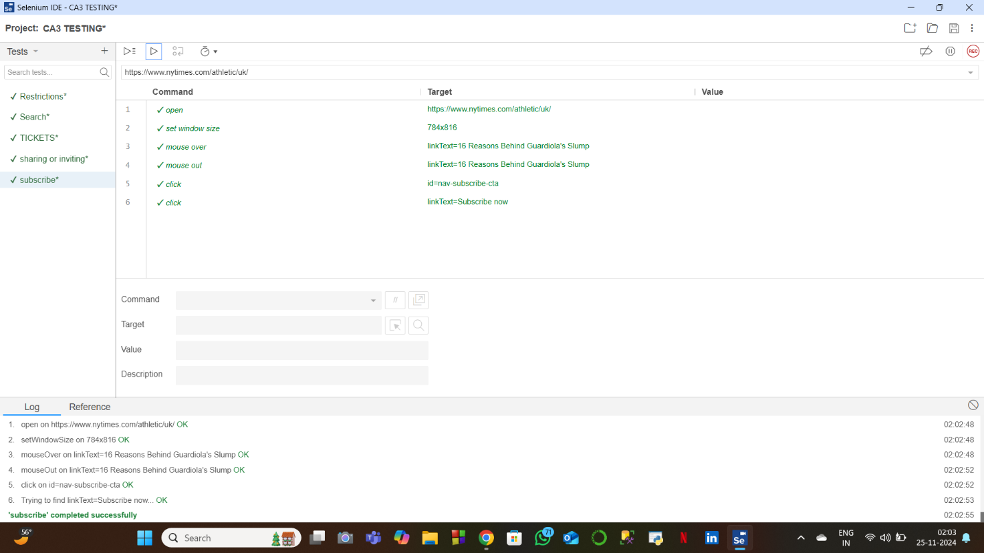

**Search Testing:**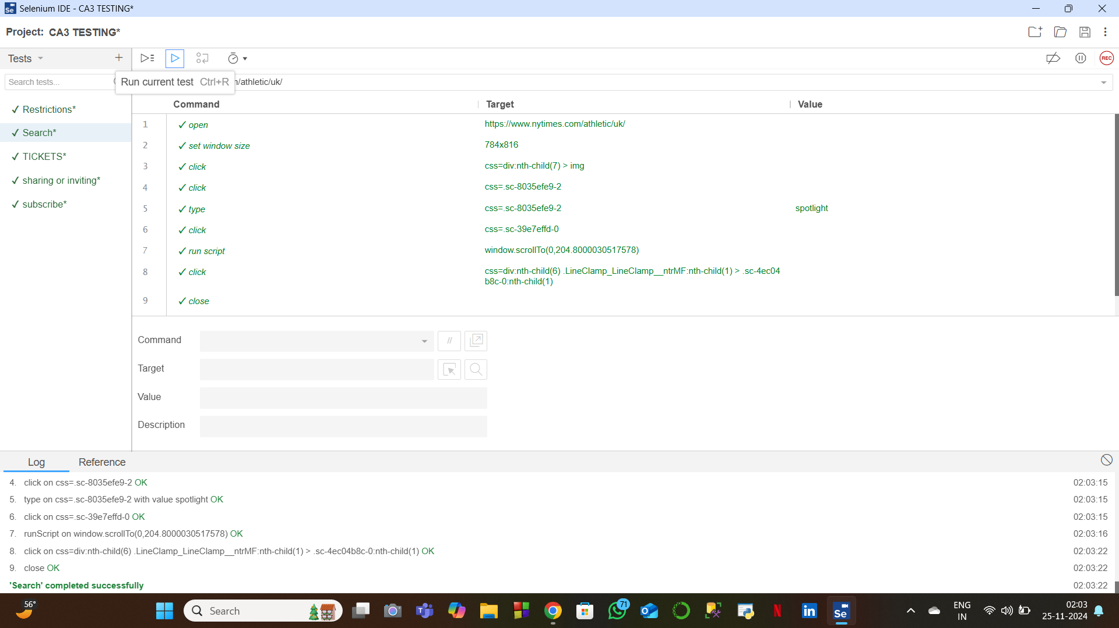

**Ticket Testing:**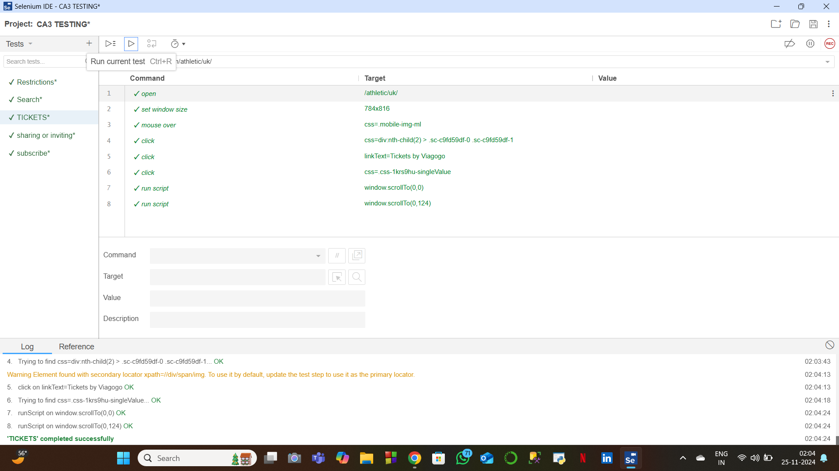

**Restrictions Testing:**

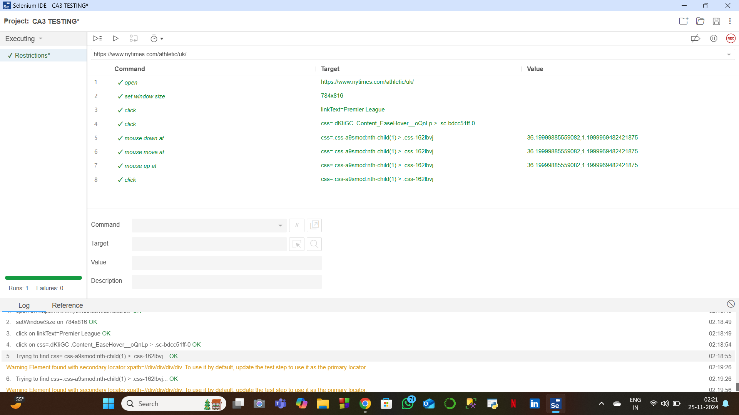

**Sharing or invite testing:**